DRUG AND ALCOHOL USE PREVENTION PROGRAM
AT VINCENNES UNIVERSITY
Health risks associated with alcohol abuse and illicit drug use
To make informed choices about drug and alcohol use, students and employees should educate themselves about the serious health consequences of use, misuse and abuse of alcohol and other drugs. The use and abuse of alcohol and other drugs can cause a number of problematic changes in behavior and physiology. Alcohol or substance dependence occurs when a person continues their use despite recurrent social, interpersonal, physical and/or legal consequences. For basic information about the health risks associated with alcohol and/or other drugs please visit:
- drugabuse.gov/sites/default/files/cadchart.pdf
- drugabuse.gov/drugs-abuse/commonly-abused-drugs-charts

Drug and alcohol resources and programs available to students and employees
Vincennes University seeks to provide a focused learning environment and to provide support and service to our community and the broader community. We recognize the best learning environments are free from the negative effects of high-risk and illegal alcohol and other drug use. The misuse and abuse of alcohol and other drugs pose a threat to individuals and the University’s ability to fulfill its educational mission. If you or someone you know is being affected by alcohol or drug use, please use the recommended resources below.

Drug and Alcohol Information and Resources for Students
Counseling Center - The Vincennes University Counseling Center is staffed by a Licensed Addictions Counselor/ Licensed Clinical Social Worker in addition to another Licensed Clinical Social Worker. Services are provided in response to a variety of presenting issues, including alcohol and other drug problems. Students may refer themselves or be referred by some other member of the VU community, whether student or employee. Students who have been charged with some type of drug or alcohol infraction may also be referred to the Counseling Center by a judicial deferral program, probation officer, judge, attorney, or any other professional within the legal system. Counseling Center services are free to all students except those referred by some element of the judicial system; those students are required to pay a one-time $50 fee in order to offset the extra paperwork and processing involved with these students. A number of hands-on tools are used during individual sessions with self-referred and court-ordered Vincennes University students. The Choices journal is a guide or outline that is used to allow the student to document his/her own opinions and views, which facilitates a more well-rounded conversation about substance use. This journal provides specific strategies and information identified by the award-winning Alcohol Skills Training approach. It gives college students the opportunity to reflect on facts, risks, and norms associated with alcohol, and then encourages them to make wise choices regarding alcohol consumption. Other tools used in sessions include the BACZone Cards, Fatal Vision Goggles and Sum-it-up kit explained earlier in this document.
The Counseling Center also maintains a page on the office website with links to a variety of self-help websites, which includes websites providing information regarding alcohol and other drugs. Students who are in a pre-contemplative or contemplative stage of examining their substance use patterns can seek out information from these websites before taking the step of actually meeting with a professional to discuss their concerns. Counseling Center personnel also consult with members of the university community who are considering how to intervene with a student or employee, or need information to facilitate a referral for services.
Vincennes University Counseling Center
Location: Shake Learning Resource Center, Room 134
Hours: Monday through Friday, 8 a.m. - 4:30 p.m.
Address: 1002 N. First Street, WAB 134
Vincennes, IN 47591
Phone: 812-888-4374
Fax: 812-888-4050

Confidential alcohol and marijuana screenings are available to all students who attend VU. You can access e-Chug or e-Toke by accessing your MyVU page and clicking on the Other resources tab and scrolling down the left-hand side.
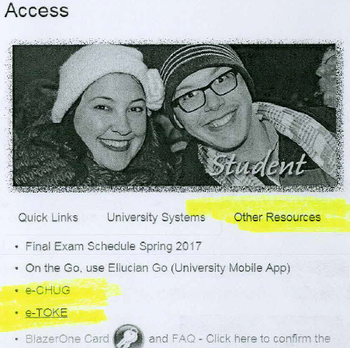

University Primary Care Center- located on the main campus in Vincennes.
UPCC
Hours of Operation
Monday - Friday
8:30 am - 4:00 pm
Phone Number
812-888-7777

Off-Campus Resources are also available and a few of the local resources are listed down below. For a more extensive list and referral assistance, please contact the Counseling Center at the number listed above.
Samaritan Center and Intervention and Addiction Services -located in the community of Vincennes
515 Bayou St in Vincennes, Indiana 47591
Call (812) 886-6800 for pricing, hours and directions. Intervention and Addiction services is also available at this location as well.

Riverfront Centre- located in the community of Vincennes
121 Buntin Street,
Suite 1 Vincennes, IN 47591
812-885-2718
Good Samaritan Hospital -located in the community of Vincennes
GSHVIN
520 South 7th Street
Vincennes, IN 47591
812-882-5220

Drug and Alcohol Information and Resources for Employees
The employee policies regarding alcohol and other drugs are available to Vincennes University employees through the Vincennes University Employee Manual, found online to every employee at https://my.vinu.edu/documents/182733/0/University+Manual.pdf/10d8cc79-023c-40eb-bf43-0231c43b55cb. The VU Drug Abuse policy, found on pages G22 and G23 of the Manual.

Vincennes University employees are not eligible to be seen in the Counseling Center as those services are reserved for the students. The Counseling Center can help with providing referral sources if needed but employees are encouraged to contact the Human Resources Office first for questions about specific benefits and resources. VU employees who are enrolled in the VU Health insurance plans can be seen at the UPCC on the main campus.
Vincennes University Human Resources Office (mailing address)
1002 N. 1st Street, Vincennes, IN 47591
Phone: 812.888.6947
Fax: 812.888.5055
Human Resources and Affirmative Action Office (physical location)
Room 119 of the Welsh Administration Building
Business hours are Monday through Friday from 8:00 a.m. to 4:30 p.m.

University Primary Care Center- located on the main campus in Vincennes.
UPCC
Hours of Operation
Monday - Friday
8:30 am - 4:00 pm
Phone Number
812-888-7777
UPCC is available to Vincennes University Employees who are enrolled in the Health Insurance plan. A licensed therapist is located at the UPCC and individual therapy appointments can be scheduled by calling the UPCC.
VU does offer an Employee Assistance Program as an additional benefit to employees. Below is a description of services and a link to access the information.
Personal issues, planning for life events or simply managing daily life can affect your work, health and family. Your GuidanceResources program provides support, resources and information for personal and work-life issues. The program is company-sponsored, confidential and provided at no charge to you and your dependents. Below are some of the highlights of the program.
- Confidential counseling- 3 session plan
- Financial Information and resources
- Legal support and resources
- Work-life solutions
- GuidanceResources Online
- Free Online Will Preparation
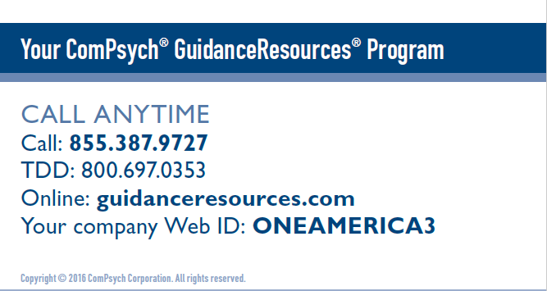

ComPsych GuidanceResources Program

Biennial Review:
The Drug-Free Schools and Campuses Regulations (34 CFR Part 86) of the Drug-Free Schools and Communities Act (DFSCA) require an institution of higher education (IHE) such as Vincennes University to certify it has adopted and implemented programs to prevent the abuse of alcohol and use or distribution of illicit drugs both by VU students and employees both on its premises and as a part of any of its activities. At a minimum each institution of higher education must annually distribute the following in writing to all students and employees:
- Standards of conduct that clearly prohibit the unlawful possession, use or distribution of illicit drugs and alcohol by students and employees
- A description of the legal sanctions under local, state, or federal law for the unlawful possession or distribution of illicit drugs and alcohol
- A description of the health risks associated with the use of illicit drugs and the abuse of alcohol
- A description of any drug or alcohol counseling, treatment, or rehabilitation or re-entry programs that are available to employees or students
- A clear statement that the institution will impose sanctions on students and employees and a description of those sanctions, up to and including expulsion or termination of employment and referral for prosecution, for violations of the standards of conduct

The law further requires that the institution conduct a biennial review of its program with the following objectives: (1) determining the effectiveness of the policy and implementing changes to the Alcohol and Other Drug (AOD) program if they are needed; and (2) to ensure that the sanctions developed are enforced consistently.
The biennial review must also include a determination as to: (1) the number of drug- and alcohol-related violations and fatalities occurring on the campus or as part of their activities that are reported to campus officials; and (2) the number and type of sanctions the IHEs impose on students or employees as a result of such violations or fatalities. Vincennes University acknowledges its legal obligation to conduct a biennial review of compliance with the Drug-Free Schools and Communities Act.
The information obtained to complete the Biennial review is a collaboration of individuals and departments throughout Vincennes University. These offices include the Dean of Students, Counseling Center, Human Resources, Campus Police, Associate Dean of Students, Residential Life, Athletic Director, Student Services Director of Jasper campus and Student activities.
Institutions of higher education are not required to submit the report to the U.S. Department of Education but will make it available upon request. For a hardcopy of the Biennial Review, all requests can be directed to Jennifer Andrews, Director of Counseling Services at Vincennes University jandrews@vinu.edu
UNLAWFUL POSSESSION, USE, OR DISTRIBUTION OF ILLICIT DRUGS AND ALCOHOL
Students
The Vincennes University Standards of Student Behavior, the student conduct code, is located in the Student Right to Know and Policies Pages within the VU Website at the following url:
https://www.vinu.edu/standards-of-student-behavior
Under section III. MISCONDUCT ACTIVITIES WHICH SUBJECT A STUDENT OR STUDENT ORGANIZATION TO DISCIPLINARY ACTION
The polices are stated that prohibit the unlawful possession, use, or distribution of illicit drugs and alcohol by students is located in the Protecting the rights, safety, and dignity of the individual section, violation 1 and 7, as well as in the Prohibited Use of Illicit Drugs and Alcohol section.
FACULTY and STAFF
The Vincennes University Manual specifies the unlawful use of unlawful possession, use, or distribution of illicit drugs and alcohol by faculty and staff. This is found in section C42 entitled Prohibited Use of Illicit Drugs and Alcohol. Also, Drug Abuse Section C106 defines Drug Abuse https://my.vinu.edu/documents/182733/0/University+Manual.pdf/10d8cc79-023c-40eb-bf43-0231c43b55cb
Descriptions of applicable legal sanctions: Vincennes University Police Department (VUPD) follows all state, local, and federal laws. All student conduct policies and sanctions are in accordance to these laws.

